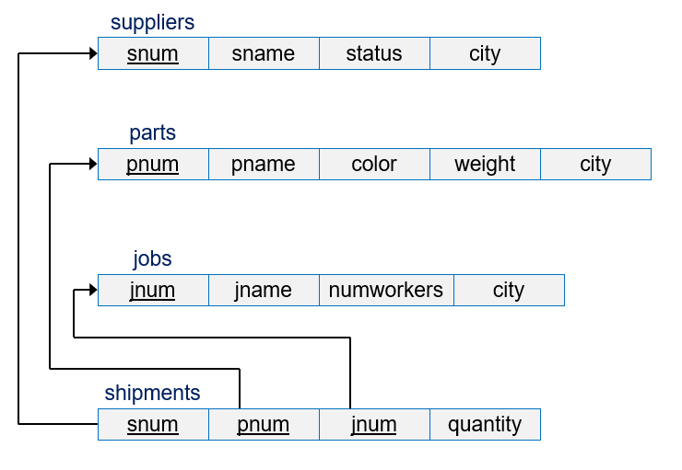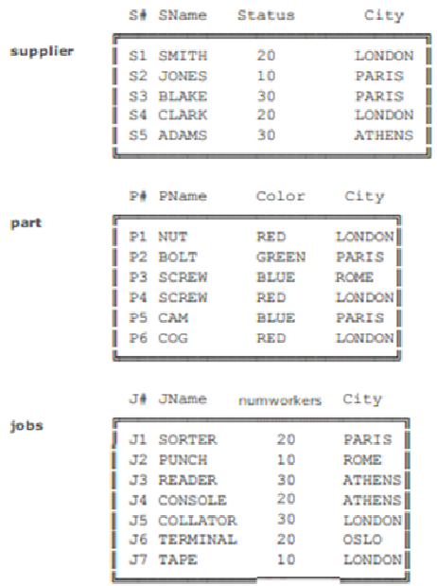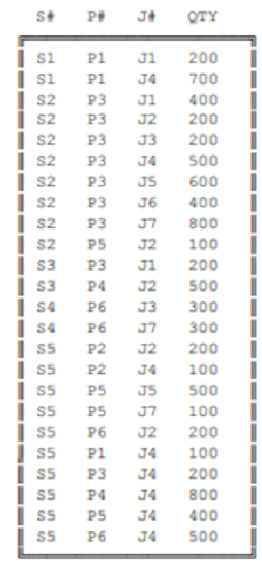

**Q1. Write the DDL for creating the Table Suppliers and Shipment.**

**Q2. Alter the table to Add the Foreign key constraint named “Supplier_Shipment”. On delete cascade, on update cascade**

**Q3. DELETE the Supplier S1, what will be effect on shipment table. Explain?**

**Q4. Select S# ‘Serial no.’, Sname ‘Name’, City from Supplier where Status >20 or city like ‘%don%’;**

**Q5. Select * into table2 from part where color<>’Red’**